Assignment 1

This is a simple software to help calculate personal income tax based on filing status and taxable income. The specifications have been provided in the previous page.

Analysis

This software is made up of one class is contains sixteen methods including the main method.The Main method is the first method which will be used to analyse this software, At the start point of the application, the selectoption method is called which displays the menu as specified in the specification from which the user will make their choice, then the user is asked to enter his or her taxable income for the personal income tax to derived.

Note that the user option and taxable income is validated using the optionValidator and incomeValidator respectively. Therefore if the user option is not one of the displayed options or the user taxable is an invalid amount like -1 then we handle such an error and display a message make the user aware of the mistake made.

The method named getTax is used to calculated and return income tax. It is calls the methods single, marriedJoint, marriedSingly and headHouseHold which also calls methods percent_10, percent_15, percent_20, percent_30, percent_34 and percent_38 when needed. Example if the user says he is single and his taxable income is 25000 then the method single is called which also calls method percent_10 altogether generate the income tax of 2500.

Design

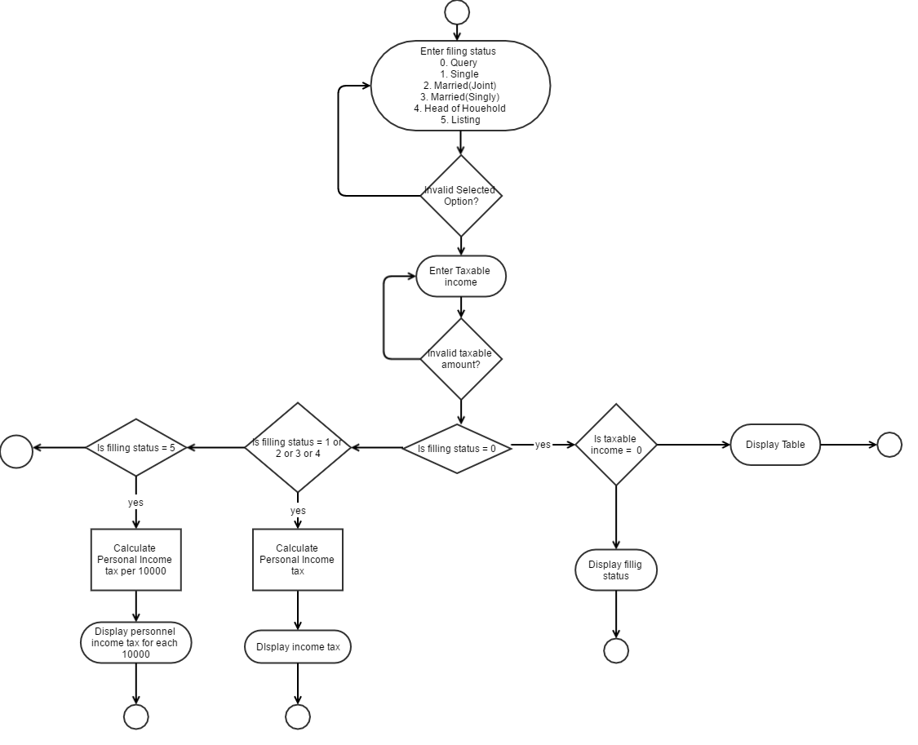

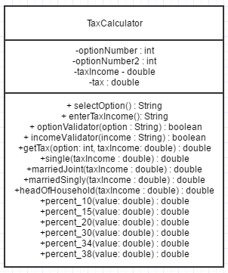

Implementation

**package** com.java.assignment;

**import** javax.swing.JOptionPane;

**public** **class** TaxCalculator {

**public** **static** **int** *optionNumber* = -1;

**public** **static** **int** *optionNumber2* = -1;

**public** **static** **double** *taxIncome*;

**public** **static** **double** *tax*;

**public** **static** **void** main(String[] args) {

TaxCalculator question = **new** TaxCalculator();

//if option is valid

**if**(question.optionValidator(question.selectOption())){

//if taxIncome is valid

**if**(question.incomeValidator(question.enterTaxIncome())){

*tax* = question.getTax(*optionNumber*, *taxIncome*);

**if**(*optionNumber* == 5 || *optionNumber* == 0){

}**else**{

String message = "Your tax for filing status \n"+*optionNumber*+""

+ "\n for taxable Income of "+*taxIncome*+" naira is "

+ "\n"+*tax*;

**if**(*optionNumber2* != -1){

message = "Your tax for filing status \n"+*optionNumber*+" , "+*optionNumber2*

+ "\n for taxable Income of "+*taxIncome*+" naira is "

+ "\n"+*tax*+" , "+question.getTax(*optionNumber2*, *taxIncome*);

}

JOptionPane.*showMessageDialog*(**null**, message, "Tax Calculator", JOptionPane.***PLAIN_MESSAGE***);

}

}**else**{

JOptionPane.*showMessageDialog*(**null**, "Restart App to use");

System.*exit*(0);;

}

}**else**{

JOptionPane.*showMessageDialog*(**null**, "Restart App to use");

System.*exit*(0);

}

System.*exit*(0);

}

/**

* Applicaton Menu

* **@return**

*/

**public** String selectOption(){

String Question = "Enter filing status \n"

+ "0. Query \n"

+ "1. Single\n"

+ "2. Married(Joint)\n"

+ "3. Married(Singly)\n"

+ "4. Head of Houehold\n"

+ "5. Listing";

//welcome to tax income calculator

**return** JOptionPane.*showInputDialog*(**null**, Question,"TAX CALCULATOR", JOptionPane.***QUESTION_MESSAGE***);

}

/**

* get user's Taxable Income

* **@return**

*/

**public** String enterTaxIncome(){

String Question = "Enter Taxable Income";

**return** JOptionPane.*showInputDialog*(**null**, Question,"TAX CALCULATOR", JOptionPane.***QUESTION_MESSAGE***);

}

/**

* this method validates the option selected by the user

* **@param** option

* **@return**

*/

**public** **boolean** optionValidator(String option) {

//if user enters a string or real number

**try**{

**if**(option.contains(",")){

String[] options = option.split(",");

*optionNumber* = Integer.*parseInt*(options[0]);

*optionNumber2* = Integer.*parseInt*(options[1]);

}**else**{

*optionNumber* = Integer.*parseInt*(option);

}

}**catch**(NumberFormatException nfe){

JOptionPane.*showMessageDialog*(**null**, "Am sorry, you entered a wrong Option","TAX CALCULATOR", JOptionPane.***ERROR_MESSAGE***);

**return** **false**;

}**catch** (NullPointerException npe) {

JOptionPane.*showMessageDialog*(**null**, "Goodbye","TAX CALCULATOR", JOptionPane.***ERROR_MESSAGE***);

**return** **false**;

}

**if**(!option.contains(",")){

**if**(*optionNumber* > 5 || *optionNumber* < 0){

JOptionPane.*showMessageDialog*(**null**, "Am sorry, That was not part of the option","TAX CALCULATOR", JOptionPane.***ERROR_MESSAGE***);

**return** **false**;

}

**if**(*optionNumber* == 0 || *optionNumber* == 5){

**return** **true**;

}

}**else**{

//option should be within the range 1-4

**if**((*optionNumber* > 4 || *optionNumber* < 1) || (*optionNumber2* > 4 || *optionNumber2* < 1)){

JOptionPane.*showMessageDialog*(**null**, "Am sorry, comma separtated Option have to be within the range 1-4","TAX CALCULATOR", JOptionPane.***ERROR_MESSAGE***);

**return** **false**;

}

}

**return** **true**;

}

/**

* Validates the user's income

* **@param** income

* **@return**

*/

**public** **boolean** incomeValidator(String income){

//if user eneters a string of a double

**try**{

*taxIncome* = Double.*parseDouble*(income);

}**catch**(NumberFormatException ex){

JOptionPane.*showMessageDialog*(**null**, "Am very Sorry, you entered an Invalid income value","TAX CALCULATOR", JOptionPane.***ERROR_MESSAGE***);

**return** **false**;

}**catch** (NullPointerException npe) {

JOptionPane.*showMessageDialog*(**null**, "Goodbye","TAX CALCULATOR", JOptionPane.***ERROR_MESSAGE***);

**return** **false**;

}

**if**(*taxIncome* < 0){

JOptionPane.*showMessageDialog*(**null**, "Am very Sorry, you entered an Invalid income value","TAX CALCULATOR", JOptionPane.***ERROR_MESSAGE***);

**return** **false**;

}

**return** **true**;

}

/**

* Generates tax for the selected option and the user's tax Income

* **@param** option

* **@param** taxIncome

* **@return**

*/

**public** **double** getTax(**int** option, **double** taxIncome){

**switch** (option) {

**case** 0:

**if**(taxIncome == 0){

String message = "Tax Rate Single\n"

+ " 10% 0-25,000\n"

+ "15% 25,001 - 135,000\n"

+ "20% 135,001 - 380,000\n"

+ "30% 380,001 - 650,000\n"

+ "34% 650,001 - 1,200,000\n"

+ "38% 1,200,000+\n"

+ "\n"

+ "Tax Rate marriedJoint\n"

+ "10% 0-50,000\n"

+ "15% 50,001 - 265,000\n"

+ "20% 265,001 - 520,000\n"

+ "30% 520,001 - 800,000\n"

+ "34% 800,001 - 1,200,000\n"

+ "38% 1,200,000+\n"

+ "\n"

+ "Tax Rate married(Singly)\n"

+ "10% 0-25,000\n"

+ "15% 25,001 - 135,000\n"

+ "20% 135,001 - 330,000\n"

+ "30% 330,001 - 600,000\n"

+ "34% 600,001 - 1,200,000\n"

+ "38% 1,200,000+\n"

+ "\n"

+ "Tax Rate HeadOfHousehold\n"

+ "10% 0-35,000\n"

+ "15% 35,001 - 165,000\n"

+ "20% 165,001 - 420,000\n"

+ "30% 420,001 - 700,000\n"

+ "34% 700,001 - 1,200,000\n"

+ "38% 1,200,000+\n";

JOptionPane.*showMessageDialog*(**null**, message, "Tax Calculator", JOptionPane.***PLAIN_MESSAGE***);

}**else**{

JOptionPane.*showMessageDialog*(**null**, "Your filing Status is \'Single\'", "Tax Calculator", JOptionPane.***PLAIN_MESSAGE***);

}

**break**;

**case** 1:

**return** single(taxIncome);

**case** 2:

**return** marriedJoint(taxIncome);

**case** 3:

**return** marriedSingly(taxIncome);

**case** 4:

**return** headOfHousehold(taxIncome);

**case** 5:

**boolean** shouldStop = **true**;

String message = "Listing \n "

+ " * Income Tax(single) Tax(Married Joint) Tax(Married Singly) Tax(HeadofhouseHold)\n";

**double** value = taxIncome;

**while**(shouldStop){

message += " * "+value+" "+single(value)+" "+marriedJoint(value)+" "+marriedSingly(value)+" "+headOfHousehold(value)+" \n";

**if**(value >= 10000){

value = value - 10000;

}**else**{

shouldStop = **false**;

}

}

JOptionPane.*showMessageDialog*(**null**, message, "Tax Calculator", JOptionPane.***PLAIN_MESSAGE***);

**break**;

**default**:

**break**;

}

**return** 0;

}

**public** **double** single(**double** taxIncome){

/*

* 10% 0-25,000

* 15% 25,001 - 135,000

* 20% 135,001 - 380,000

* 30% 380,001 - 650,000

* 34% 650,001 - 1,200,000

* 38% 1,200,000+

*/

**if**(taxIncome <= 25000){

**return** percent_10(taxIncome);

}**else** **if**(taxIncome > 25000 && taxIncome < 135000){

**return** percent_10(25000) + percent_15(taxIncome - 25000);

}**else** **if**(taxIncome > 135000 && taxIncome < 380000){

**return** percent_15(135000) + percent_20(taxIncome - 135000);

}**else** **if**(taxIncome > 380000 && taxIncome < 650000){

**return** percent_20(380000) + percent_30(taxIncome - 380000);

}**else** **if**(taxIncome > 650000 && taxIncome < 1200000){

**return** percent_30(650000) + percent_34(taxIncome - 650000);

}**else** **if**(taxIncome > 1200000){

**return** percent_34(1200000) + percent_38(taxIncome - 1200000);

}

**return** 0;

}

**public** **double** marriedJoint(**double** taxIncome){

/*

* 10% 0-50,000

* 15% 50,001 - 265,000

* 20% 265,001 - 520,000

* 30% 520,001 - 800,000

* 34% 800,001 - 1,200,000

* 38% 1,200,000+

*/

**if**(taxIncome <= 50000){

**return** percent_10(taxIncome);

}**else** **if**(taxIncome > 50000 && taxIncome < 265000){

**return** percent_10(50000) + percent_15(taxIncome - 50000);

}**else** **if**(taxIncome > 265000 && taxIncome < 520000){

**return** percent_15(265000) + percent_20(taxIncome - 265000);

}**else** **if**(taxIncome > 520000 && taxIncome < 800000){

**return** percent_20(520000) + percent_30(taxIncome - 520000);

}**else** **if**(taxIncome > 800000 && taxIncome < 1200000){

**return** percent_30(800000) + percent_34(taxIncome - 800000);

}**else** **if**(taxIncome > 1200000){

**return** percent_34(1200000) + percent_38(taxIncome - 1200000);

}

**return** 0;

}

**public** **double** marriedSingly(**double** taxIncome){

/*

* 10% 0-25,000

* 15% 25,001 - 135,000

* 20% 135,001 - 330,000

* 30% 330,001 - 600,000

* 34% 600,001 - 1,200,000

* 38% 1,200,000+

*/

**if**(taxIncome <= 25000){

**return** percent_10(taxIncome);

}**else** **if**(taxIncome > 25000 && taxIncome < 135000){

**return** percent_10(25000) + percent_15(taxIncome - 25000);

}**else** **if**(taxIncome > 135000 && taxIncome < 330000){

**return** percent_15(135000) + percent_20(taxIncome - 135000);

}**else** **if**(taxIncome > 330000 && taxIncome < 600000){

**return** percent_20(330000) + percent_30(taxIncome - 330000);

}**else** **if**(taxIncome > 600000 && taxIncome < 1200000){

**return** percent_30(600000) + percent_34(taxIncome - 600000);

}**else** **if**(taxIncome > 1200000){

**return** percent_34(1200000) + percent_38(taxIncome - 1200000);

}

**return** 0;

}

**public** **double** headOfHousehold(**double** taxIncome){

/*

* 10% 0-35,000

* 15% 35,001 - 165,000

* 20% 165,001 - 420,000

* 30% 420,001 - 700,000

* 34% 700,001 - 1,200,000

* 38% 1,200,000+

*/

**if**(taxIncome <= 35000){

**return** percent_10(taxIncome);

}**else** **if**(taxIncome > 35000 && taxIncome < 165000){

**return** percent_10(35000) + percent_15(taxIncome - 35000);

}**else** **if**(taxIncome > 165000 && taxIncome < 420000){

**return** percent_15(165000) + percent_20(taxIncome - 165000);

}**else** **if**(taxIncome > 420000 && taxIncome < 700000){

**return** percent_20(420000) + percent_30(taxIncome - 420000);

}**else** **if**(taxIncome > 700000 && taxIncome < 1200000){

**return** percent_30(700000) + percent_34(taxIncome - 700000);

}**else** **if**(taxIncome > 1200000){

**return** percent_34(1200000) + percent_38(taxIncome - 1200000);

}

**return** 0;

}

**public** **double** percent_10(**double** value){

**return** 0.10 * value;

}

**public** **double** percent_15(**double** value){

**return** 0.15 * value;

}

**public** **double** percent_20(**double** value){

**return** 0.20 * value;

}

**public** **double** percent_30(**double** value){

**return** 0.30 * value;

}

**public** **double** percent_34(**double** value){

**return** 0.34 * value;

}

**public** **double** percent_38(**double** value){

**return** 0.38 * value;

}

}

Output (Screenshot)

